**Experiment No:** 1

**Experiment Name:** Detecting Comments in C/C++ Code

**Problem Structure:**

Write a C/C++ program that takes a line of code as input and determines whether it is a single-line comment (e.g.: // comment, int x; //declare variable) or a multi-line comment (e.g., /* comment */, int x = 10; /* variable declare and value assign */).

**Procedure:**

**Input Collection:**

* Use the getline function to collect a line of code from the user.

**Comment Detection:**

* Implement a logic that checks for single-line comments and multi-line comments in the input.
* Utilize a stack-based approach to handle multi-line comment detection.

**Output Presentation:**

* Display the result, indicating whether the input line is a single-line comment, a multi-line comment, or not a comment at all.

**Code Structure:**

* Use structured programming techniques to organize the code logically.
* Implement functions or blocks for input collection, comment detection, and output presentation.

**Testing:**

* Test the program with various inputs, including single-line comments, multi-line comments, and code without comments.
* Verify that the program correctly identifies the nature of each input.

**Code:**

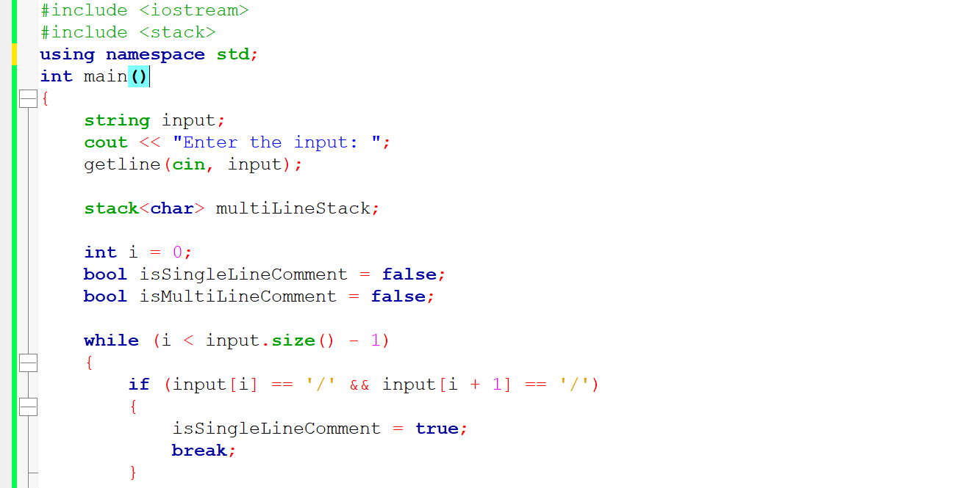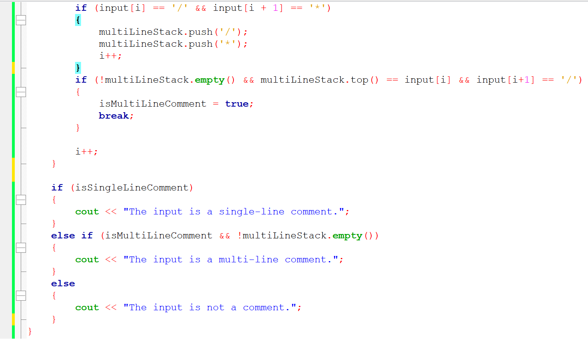

**Input-Output:**

